1. In today’s session we are going to understand and implement the concept related to Angular Forms.

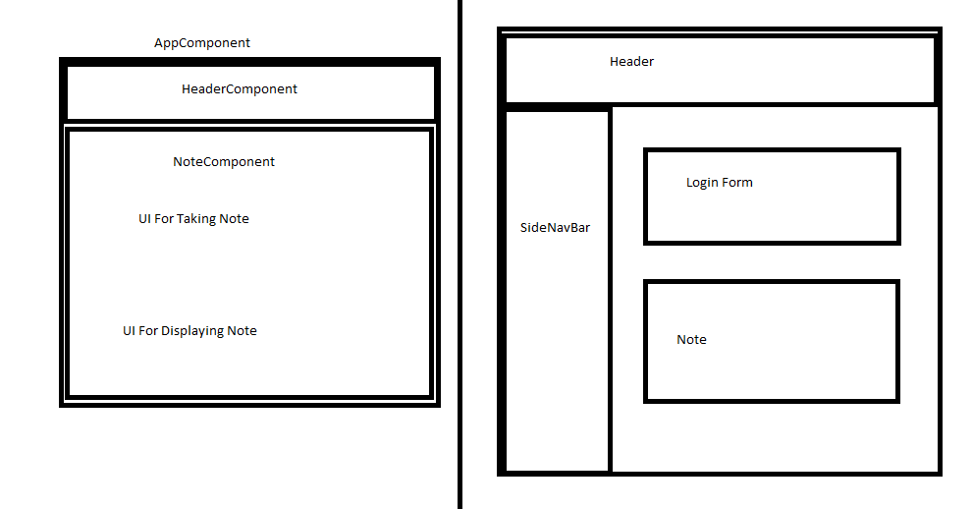

1. What is form and why do we need it?
2. Angular supports Two types of forms
   1. Template Driven Form: It is mainly used for basic data entry operations or accepting the data for achieving simple objectives like login, signUp , filing form for any operations.
      1. For template driven form angular provides
         1. ngForm
         2. ngModel
         3. Form reference and control reference
         4. Directives for validations
            1. Required
            2. Minlength
            3. Email
         5. FormModule
   2. Reactive Form (Model Driven Form): It is mainly used to manage the data workflow and state of the form based on data changes
      1. To implement Reactive Forms Angular Support
         1. FormGroup
         2. FormControl
         3. FormBuilder
         4. Validators
            1. Required
            2. Minlength
         5. In reactive form the name of formgroup and control must be same in .ts file, .html file as well as model class file
3. Various states of control or form supported by Angular are
   1. Input fields have the following states:

* $untouched The field has not been touched yet
* $touched The field has been touched
* $pristine The field has not been modified yet
* $dirty The field has been modified
* $invalid The field content is not valid
* $valid The field content is valid

They are all properties of the input field, and are either true or false.

Forms have the following states:

* $pristine No fields have been modified yet
* $dirty One or more have been modified
* $invalid The form content is not valid
* $valid The form content is valid
* $submitted The form is submitted

1. Routing and Navigation

Gurubaran:- Seems there is local issue, Please check and seek support from local team at your end. All others are able to hear and see my screen